10. Hook Kick

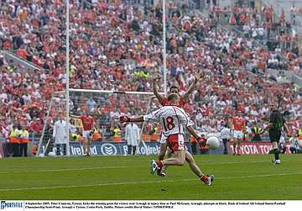

- Introduce
- Demonstrate
- Execute
- Attend

Release ball into hand on kicking side

The Hook Kick is a kicking technique used in Gaelic Football. It is predominantly used to shoot for points but is also used to pass to a team mate at an angle to the player in possession.

Step forward with non-kicking foot

Look out for:
- Not pointing the shoulders towards the target
- Dropping the ball with the opposite hand to the kicking foot
- Lifting the head too early

Kick with the inside of the foot

Follow through across the body
Pg. 61-66 FFD

Hook Kick

Practice the Technique


Partner Kick
Each Player in turn Hook Kicks the ball to their partner

Around the Square
A, Hook Kicks to B who fist passes to C who hook kicks to D and so on.
Kick and Move
Players Hook Kick to each other while stationary and while moving between cones

Develop the Skill


Bull’s Eye
Players attempt to land the ball in the centre square or circle by Hook Kicking the ball

Hooked
No goalkeepers, score by Hook Kicking the ball between the cones



